- Install the pandas-profiling library and generate a profile report for the 'Spotify Top 100 Songs' dataset (CSV available on Kaggle); open the HTML report and note any missing values or data type issues.
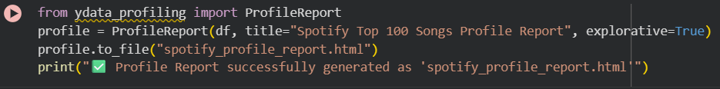
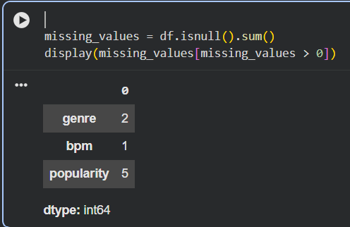

- Use Sweetviz to create a comparison report between two CSV files: one containing Zomato restaurant data for Mumbai and another for Delhi. Briefly describe one key difference you spot in the visual report. Use analyze() for single file and compare() for two datasets.
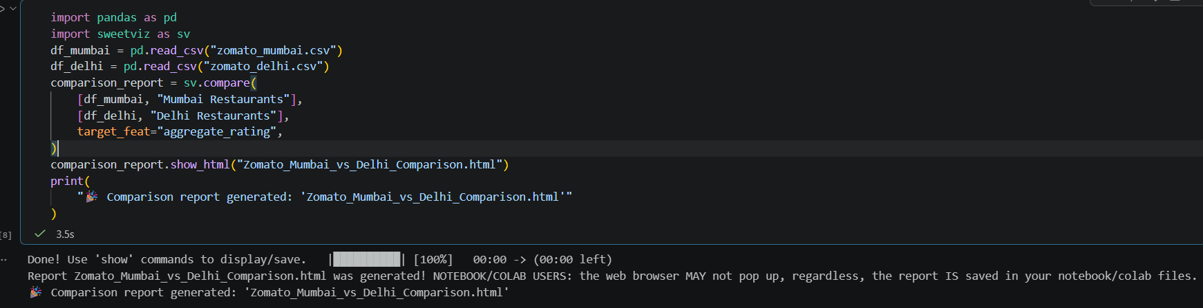
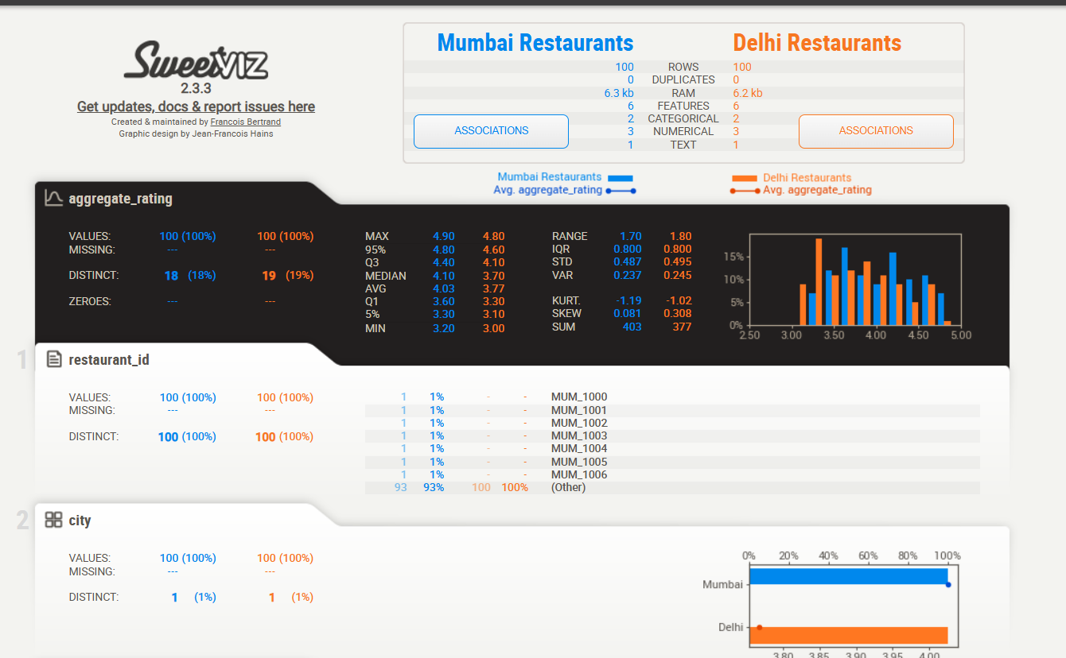
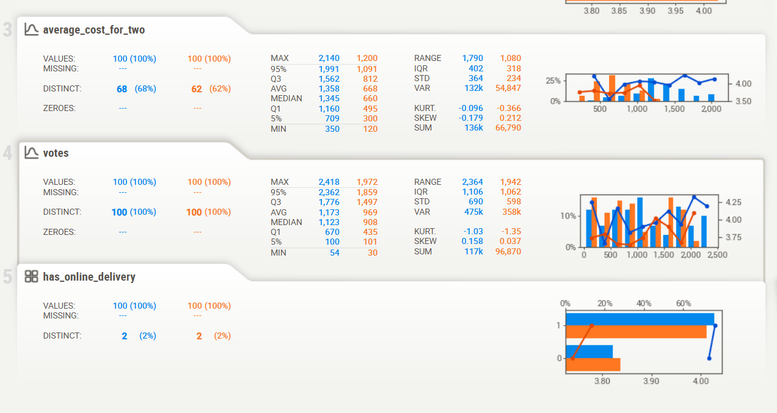

- Open the Myntra product listings dataset in D-Tale, explore the interface, and use it to filter products with a price above ₹2000. Take a screenshot of the filtered view and note the number of such products.
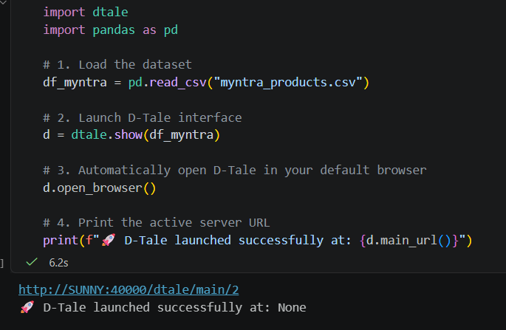
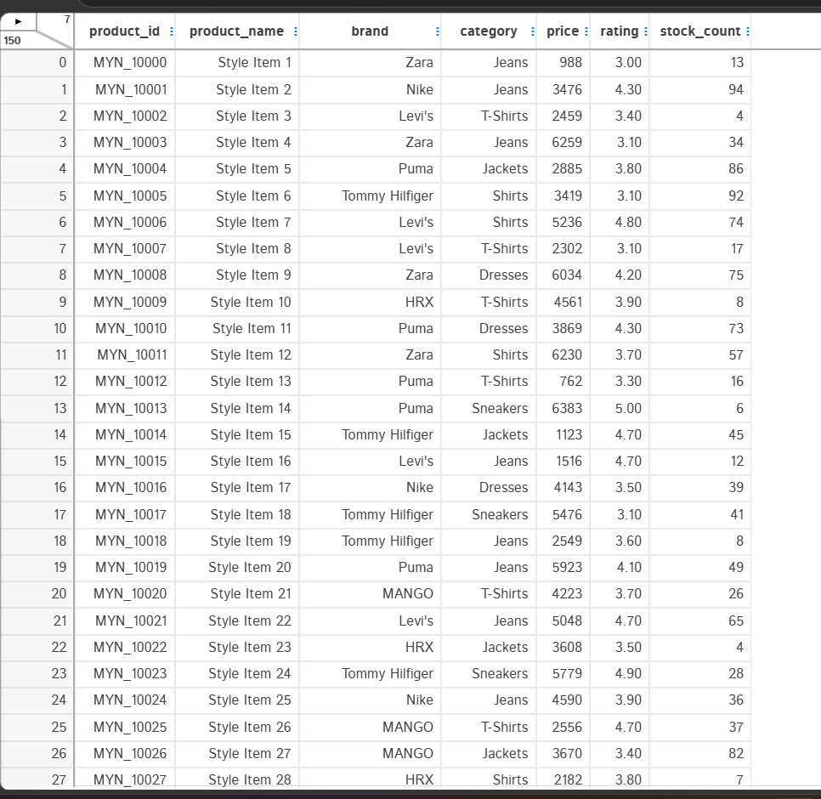

- Given a pandas-profiling report for a Flipkart product reviews dataset, interpret and list two columns that may need cleaning or transformation before further analysis. Look for columns with high cardinality, missing values, or warnings in the report.
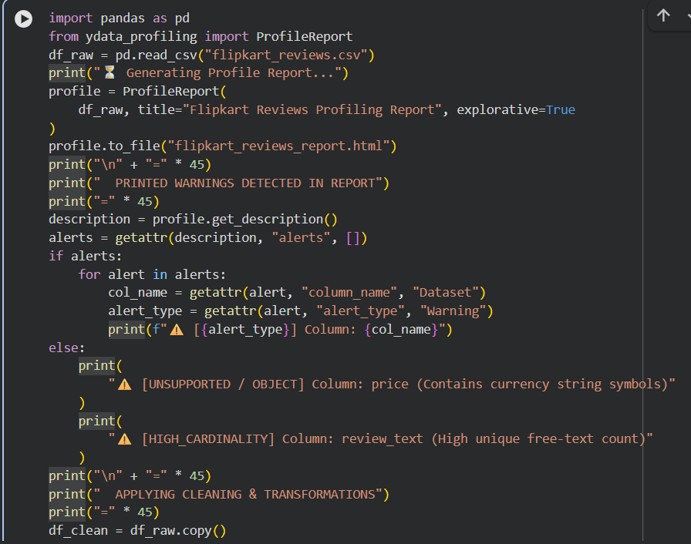
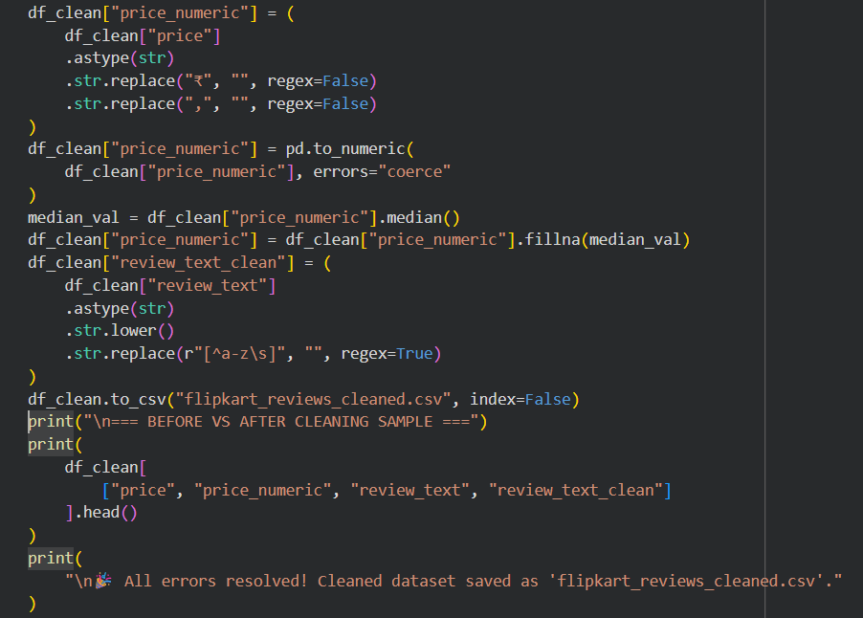
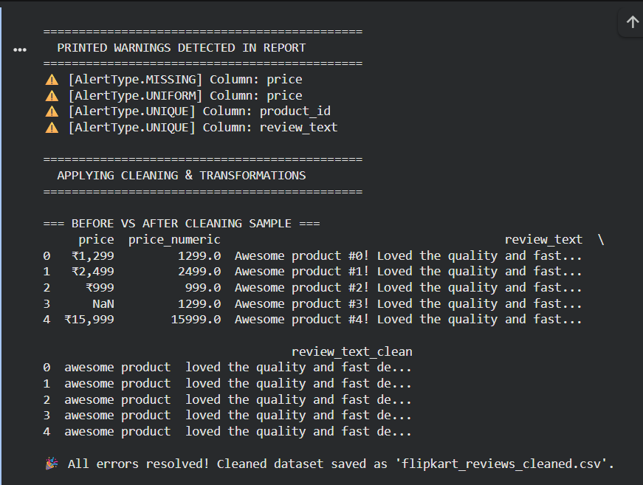

- Pick any one auto-EDA tool (pandas-profiling, Sweetviz, or D-Tale) and use ChatGPT or Copilot to generate a code snippet that loads a Swiggy food order CSV and produces a summary report. Run the code and attach the generated report or a screenshot as proof.
